ASSIGNMENT 1

Design a login page look like facebook with follow requirements:

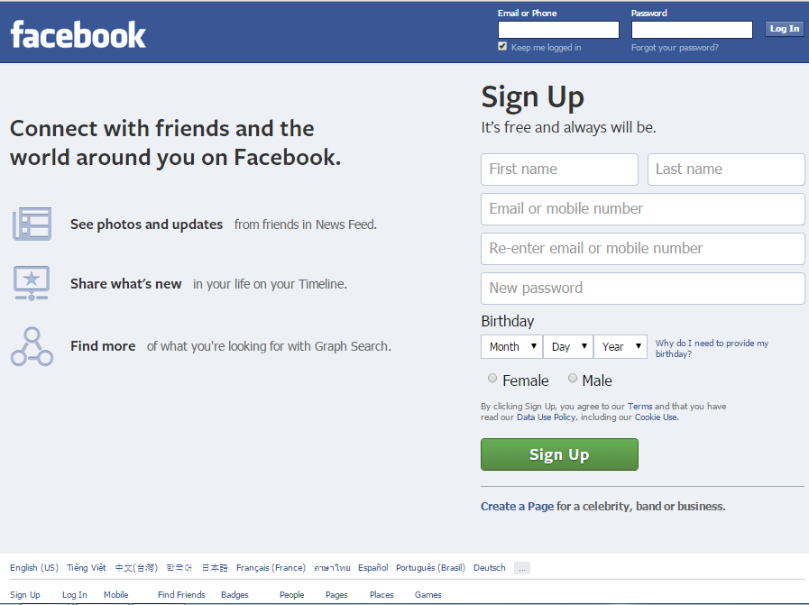

1. Design a structure of this page
2. Code the head section with title and metadata for this page.
3. Code Sign Up form and using HTML validation control to validate the input data by follow rules:
   1. First Name and Last Name don’t include the number and maximum 20 characters.
   2. Email must be correct email form.
   3. Password should be correct password form and minimum 8 characters.

ASSIGNMENT 2

Design a form look like this form with follow the requirements bellow:

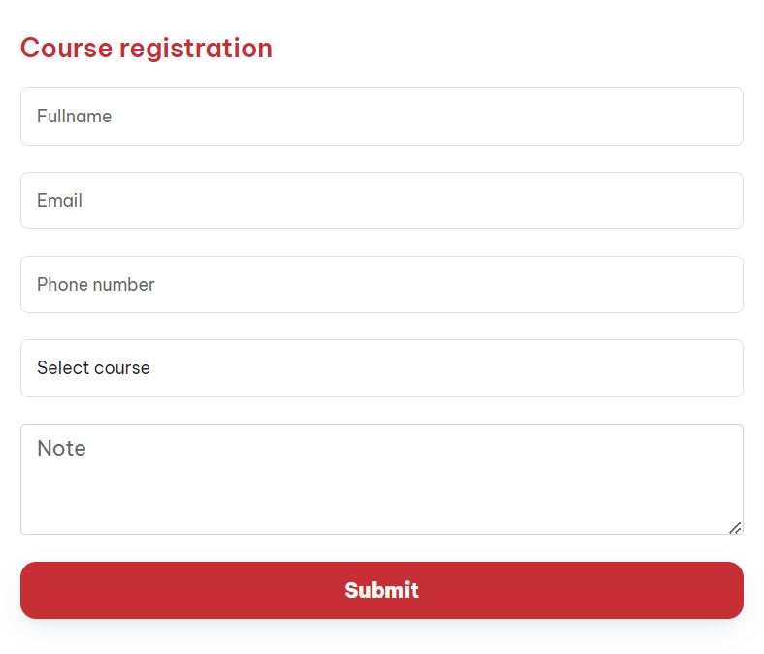

1. [Fullname] field doesn’t include any number and not be empty
2. [Email] field must be the correct email form.
3. [Phone number] field isn’t empty and only accepts number
4. [Select Course] field must have your choice